CERTIFICATE

**This is to certify that Rupali Sahoo of class XII has carried out the project work as per the guidelines by Ms. Meeta P. They had prepared Purple Fish Online BookStore project under the supervision of Ms. Meeta P. during the academic year 2016-17 in K.D.Ambani Vidyamandir.**

**INTERNAL EXAMINER EXTERNAL EXAMINER**

**Ms. Meeta P.**

**PRINCIPAL**

|  |  |  |
| --- | --- | --- |
| **S.No** | **Topic** |  |
| **1** | **Preface** |  |
| **2** | **Acknowledgement** |  |
| **3** | **Hardware / Software Specification** |  |
| **4** | **Introduction** |  |
| **5** | **Objective & Scope** |  |
| **6** | **Screen Shots** |  |
| **7** | **Coding** |  |
| **8** | **Bibliography** |  |

**INDEX**

**PREFACE**

**Since the development of computers. They have been used in a large number of applications of different conventions. They are used to carry out complex calculations, storing bulk data.**

**The inherent capability of computers to store large amount of data, retrieve data whenever needed and analyzing the data makes them a very important companion in the success of any company. They have become an important part of today’s industries because of their capabilities to automate the tedious tasks in a more efficient and effective manner.**

**The advancement in the field of information Technology has raised the need for the trained computer professionals.**

**Project designing in Informatics Practices is a part of CBSE syllabus in class XII, It help students for software exposure as to gain control over programming languages. Such Project making plays a vital role to implement theoretical concepts to enhance their practical knowledge and make them aware about the role situations of the software application.**

**ACKNOWLEDGEMENT**

**We would like to express our sincere thanks and gratitude to our Principal and our IP teacher Ms. Meeta P. for her valuable help in completing this project.**

**In all, the project has been challenging and exhilarating experience in terms of analyzing and designing a full -fledged**

**PURPLE FISH ONLINE BOOKSTORE.**

**Your Faithfully,**

**Rupali Sahoo**

**HARDWARE SPECIFICATION**

|  |  |  |
| --- | --- | --- |
| **Sr.**  **No.** | **Components** | **Description** |
| **1** | **System** | **IBM** |
| **2** | **Processor** | **Intel (R) Pentium (R) D CPU 3.00 GHz** |
| **3** | **Main Memory ( RAM)** | **2 GB** |
| **4** | **Hard Disk** | **300 GB** |
|  |  |  |

**SOFTWARE SPECIFICATION**

|  |  |  |
| --- | --- | --- |
| **Sr.**  **No.** | **Software Used** | **Description** |
| **1** | **Net beans IDE 6.9.1** | **Used for Project**  **Development for Frontend programming** |
| **2** | **MYSQL Server 5.1** | **Used for Project**  **Development for Backend programming** |
| **3** | **Microsoft Office 2007** | **For documentation** |

**INTRODUCTION**

**The NetBeans IDE is an award-winning integrated development environment available for Windows, Mac, and Linux etc. The NetBeans project consists of an**[**open-source IDE**](http://netbeans.org/features/index.html)**and an**[**application platform**](http://netbeans.org/features/platform/index.html)**that enable developers to rapidly create web, enterprise, desktop, and mobile applications using the Java platform, as well as JavaFX, PHP, JavaScript and C/C++.**

**MySQL is the world's most used open source**[**relational database management system**](http://en.wikipedia.org/wiki/Relational_database_management_system)**(RDBMS) .The**[**SQL**](http://en.wikipedia.org/wiki/SQL)**phrase stands for Structured Query Language.**

**The MySQL development project has made its**[**source code**](http://en.wikipedia.org/wiki/Source_code)**available under the terms of the**[**GNU General Public License**](http://en.wikipedia.org/wiki/GNU_General_Public_License)**, as well as under a variety of**[**proprietary**](http://en.wikipedia.org/wiki/Proprietary_software) **agreements. MySQL is now owned by**[**Oracle Corporation**](http://en.wikipedia.org/wiki/Oracle_Corporation)**.**

**MySQL is an open source database management system and is used in some of the most frequently visited websites on the Internet,**[**Nokia.com**](http://en.wikipedia.org/wiki/Nokia)**,**[**YouTube**](http://en.wikipedia.org/wiki/YouTube)**and as previously mentioned, Wikipedia, Google, Facebook and Twitter.**

**In this Project Netbeans 6.9.1 is used as Frontend and MySQL is used as Backend.**

**OBJECTIVE AND SCOPE**

There is a shift in the trend of buying books from a conventional store. Lots and lots of people today are using the web to shop for their favorite book and the main reason for this shift in the trend is the benefits of shopping online over a conventional book store.

1. Convenience: When you shop online you save your precious time and energy as you do not have to wander from one store to another in search of a book. Other than that there are no fixed hours for an online book store.

2. No limited choice- A conventional store has limited space to display and store its book but this is not the case with an online store. Most of the stores have huge databases and in case you do not see what you were looking for then you can move on to another store which is just a click away.

3. Price Comparison: When you enter a store, you have to settle down at a price the vendor has placed on the particular book. But when you are shopping online you have the choice to compare the price with number of other stores.

4. Easy access to consumer reviews: When you are buying from an online store, you get the chance to go through the reviews of people who have previously purchased that book. This will give you the beforehand knowledge of that particular book.

5. Huge discounts: These online stores offer a great deal of discount coupons from time to time that helps you in saving money on your purchases

**Screen Shots and Coding**

**WELCOME FRAME**



**CODING:**

import java.awt.Color;

getContentPane().setBackground(Color.BLACK);

**BUTTON CODING:**

this.setVisible(false);

frame2 a=new frame2();

a.setVisible(true);

**LOGIN FRAME**

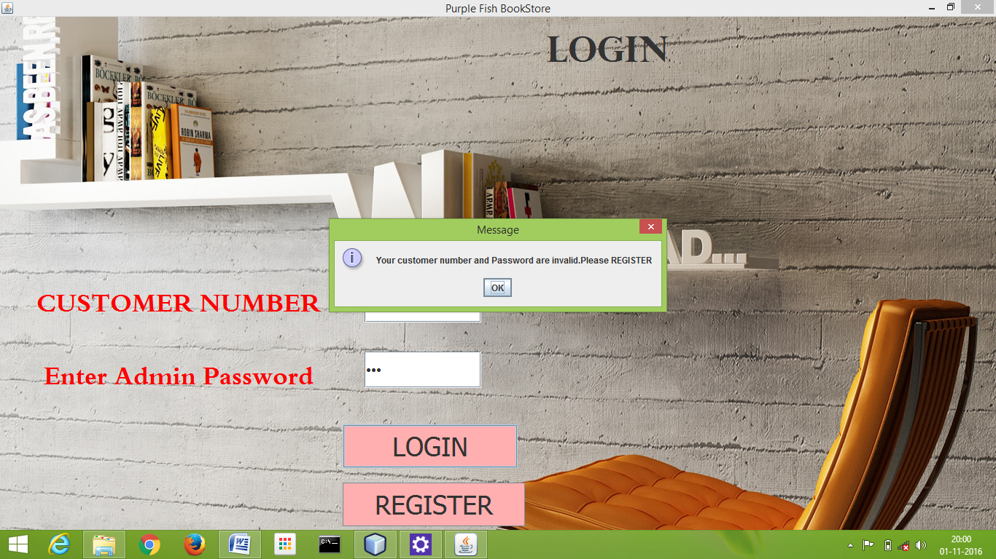

**CODING:**

import com.mysql.jdbc.Connection;

import com.mysql.jdbc.Statement;

import java.awt.Color;

import java.sql.DriverManager;

import java.sql.ResultSet;

import javax.swing.JOptionPane;

getContentPane().setBackground(Color.blue);

**LOGIN BUTTON CODING:**

String p="";

String pass=jPasswordField1.getText();

String customerID=usernameTF.getText();

try

{ Class.forName("java.sql.Driver");

Connection con=(Connection) DriverManager.getConnection("jdbc:mysql://localhost:3306/ipproject","root","computer");

Statement stmt=(Statement) con.createStatement();

String q="Select*from register where customer_id="+customerID+";";

ResultSet r=stmt.executeQuery(q);

while(r.next())

{

p=r.getString("password");}

if(p.equals(pass))

{JOptionPane.showMessageDialog(null,"welcome");

this.setVisible(false);

frame5 a=new frame5();

a.setVisible(true);

}

else

JOptionPane.showMessageDialog(null,"Your customer number and Password are invalid.Please REGISTER");

stmt.close();

con.close();

}

catch(Exception e)

{ JOptionPane.showMessageDialog(this,e.getMessage()

);

}

String p="";

String pass=jPasswordField1.getText();

String customerID=usernameTF.getText();

try

{ Class.forName("java.sql.Driver");

Connection con=(Connection) DriverManager.getConnection("jdbc:mysql://localhost:3306/ipproject","root","computer");

Statement stmt=(Statement) con.createStatement();

String q="Select*from register where customer_id="+customerID+";";

ResultSet r=stmt.executeQuery(q);

while(r.next())

{

p=r.getString("password");}

if(p.equals(pass))

{

try{

Class.forName("java.sql.Driver");

Connection conn=(Connection) DriverManager.getConnection("jdbc:mysql://localhost:3306/ipproject","root","computer");

String q2= "DELETE FROM addbooks WHERE customer_id = "+customerID+ ";";

Statement st=(Statement) con.createStatement();

st.executeUpdate(q2);

st.close();

conn.close();

}

catch(Exception e)

{ JOptionPane.showMessageDialog(this,e.getMessage());

} JOptionPane.showMessageDialog(null,"welcome");

this.setVisible(false);

frame3 a=new frame3();

a.setVisible(true); }

else

JOptionPane.showMessageDialog(null,"INVALID");

stmt.close();

con.close();

}

catch(Exception e)

{ JOptionPane.showMessageDialog(this,e.getMessage) );

}

**REGISTER BUTTON CODING:**

this.setVisible(false);

framenewuser a=new framenewuser();

a.setVisible(true);

**REGISTER FRAME**

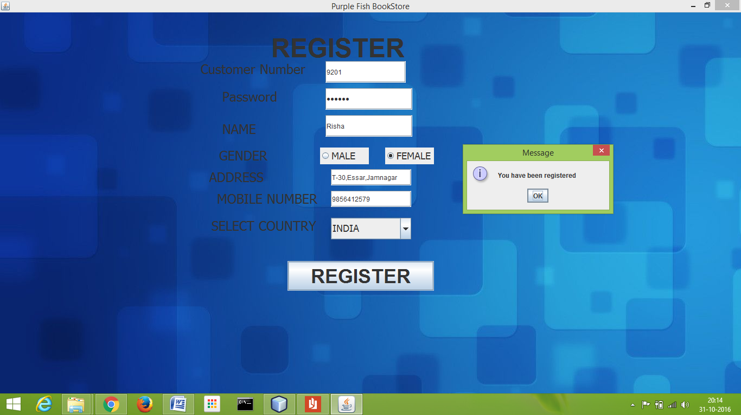

**CODING:**

import javax.swing.JOptionPane;

import java.sql.*;

**REGISTER BUTTON CODING:**

String name=nameTF.getText();

String address=addressTF.getText();

String customer_id=idTF.getText();

String radiobtn=" ";

String mobileno=mobileTF.getText();

String password=jPasswordField1.getText();

if( maleradio.isSelected()==true)

radiobtn="male";

else if(femaleradio.isSelected() == true)

radiobtn="female";

if(mobileno.isEmpty())

{

JOptionPane.showMessageDialog(this,"Please enter mobile number");

}

if(customer_id.isEmpty())

{ JOptionPane.showMessageDialog(this,"Please enter customer id!!!!"); }

if (mobileno.length()>10)

JOptionPane.showMessageDialog(this," Please Enter valid Mobile number");

try{

Class.forName("java.sql.DriverManager"); Connection con= DriverManager.getConnection("jdbc:mysql://localhost:3306/ipproject","root","computer");

Statement st=con.createStatement();

String q="insert into register values('"+name+"','"+address+"','"+mobileno+"','"+customer_id+"','"+radiobtn+"','"+password+"');";

st.executeUpdate(q);

JOptionPane.showMessageDialog(this,"You have been registered");

this.setVisible(false);

frame3 a=new frame3();

a.setVisible(true);

}

catch(Exception e)

{

JOptionPane.showMessageDialog(this,"Please enter another customer id.");} }

**BOOKSTORE FRAME**

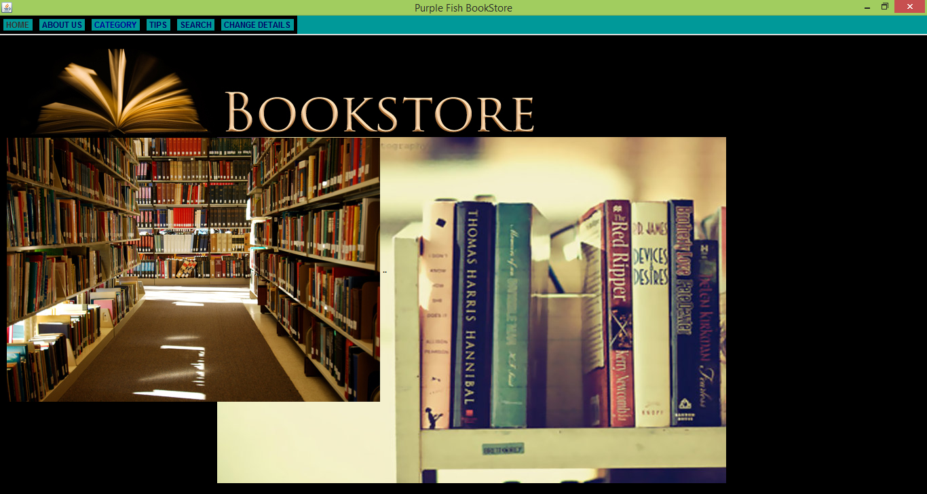

**CODING:**

import java.awt.Color;

getContentPane().setBackground(Color.black);

private void jMenuItem1ActionPerformed(java.awt.event.ActionEvent evt) {

// TODO add your handling code here:

this.setVisible(false);

frame2 a=new frame2();

a.setVisible(true);

}

private void jMenuItem2ActionPerformed(java.awt.event.ActionEvent evt) {

// TODO add your handling code here:

System.exit(0);

}

jMenuItem3ActionPerformed(java.awt.event.ActionEvent evt) {

// TODO add your handling code here:

this.setVisible(false);

frame4 a=new frame4();

a.setVisible(true);

}

private void jMenuItem4ActionPerformed(java.awt.event.ActionEvent evt) {

// TODO add your handling code here:

this.setVisible(false);

frame5 a=new frame5();

a.setVisible(true);

}

private void jMenuItem5ActionPerformed(java.awt.event.ActionEvent evt) {

// TODO add your handling code here:

this.setVisible(false);

frameTips a=new frameTips();

a.setVisible(true);

}

private void jMenuItem6ActionPerformed(java.awt.event.ActionEvent evt) {

// TODO add your handling code here:

this.setVisible(false);

changeuserdetail a=new changeuserdetail();

a.setVisible(true);

}

private void jMenuItem7ActionPerformed(java.awt.event.ActionEvent evt) {

// TODO add your handling code here:

this.setVisible(false);

finalbillpage a=new finalbillpage();

a.setVisible(true);

**ABOUT US FRAME**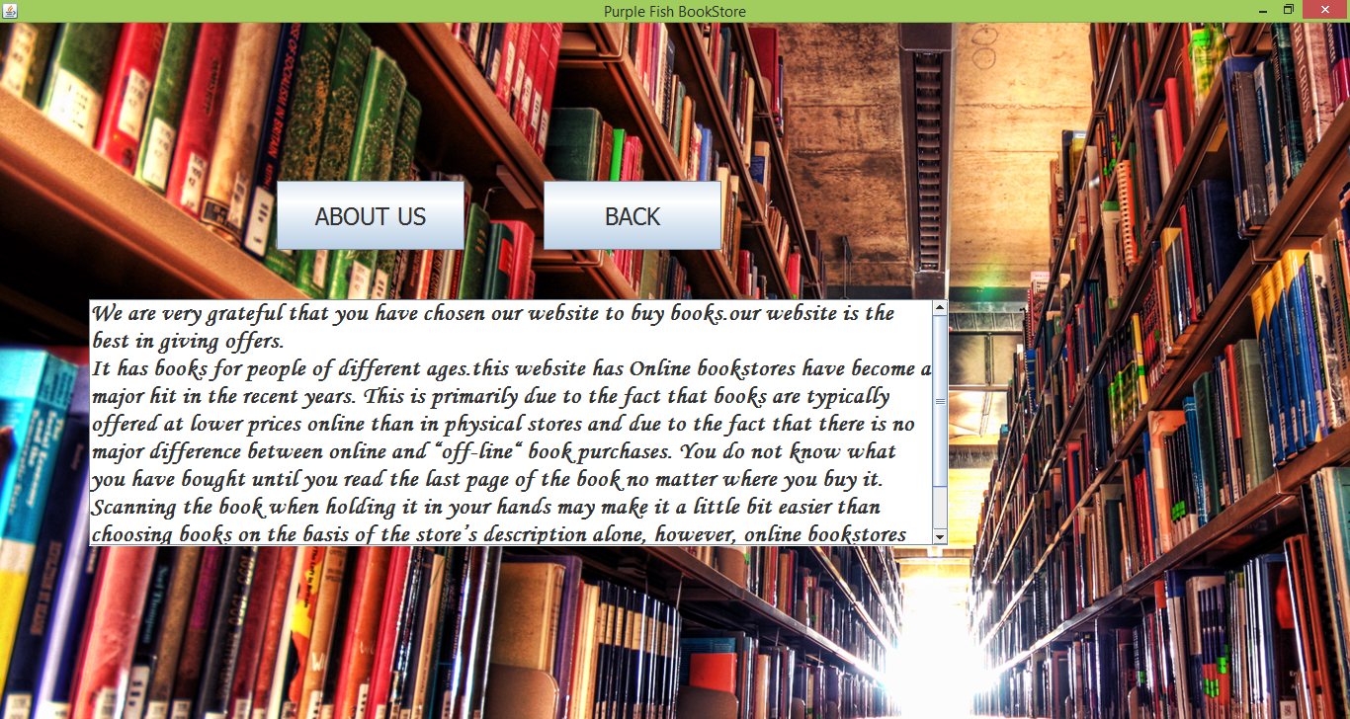

**ABOUT US BUTTON CODING:**

jTextArea1.setText("We are very grateful that you have chosen our website to buy books.our website is the best in giving offers."+"\n"+ "It has books for people of different ages.this website has " + "Online bookstores have become a major hit in the recent years. This is primarily due to the fact that books are typically offered at lower prices online than in physical stores and due to the fact that there is no major difference between online and “off-line“ book purchases. You do not know what you have bought until you read the last page of the book no matter where you buy it. Scanning the book when holding it in your hands may make it a little bit" + " easier than choosing books on the basis of the store’s description alone, however, online bookstores"+ " typically offer customer reviews which reveal more about the book than its physical appearance and a"+ " quick glance of its content.");

**BACK BUTTON CODING:**

this.setVisible(false);

frame3 a=new frame3();

a.setVisible(true);

**CBSE REFRENCE BOOKS FRAME**

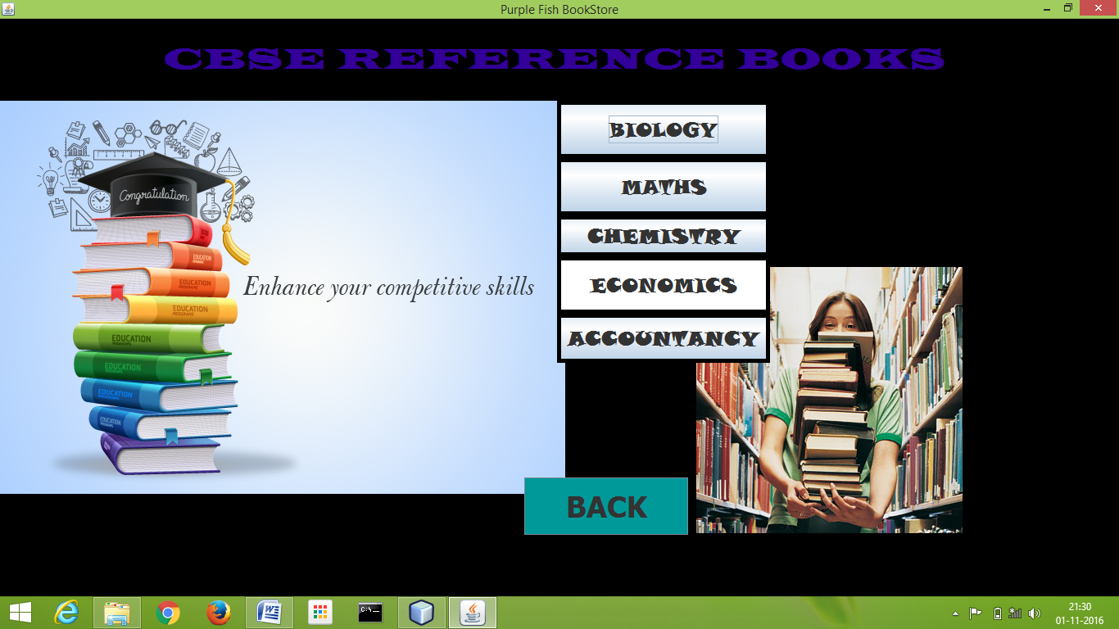

**CODING:**

import java.awt.Color;

getContentPane().setBackground(Color.black);

**BIOLOGY BUTTON CODING:**

this.setVisible(false);

frameBIO a=new frameBIO();

a.setVisible(true);

**MATHS BUTTON CODING:**

this.setVisible(false);

frameMath a=new frameMath();

a.setVisible(true);

**CHEMISTRY BUTTON CODING:**

this.setVisible(false);

frameCHEM a=new frameCHEM();

a.setVisible(true);

**ECONOMICS BUTTON CODING:**

this.setVisible(false);

framECO a=new framECO();

a.setVisible(true);

**ACCOUNTANCT BUTTON CODING:**

this.setVisible(false);

ACC1 a=new ACC1();

a.setVisible(true);

**BACK BUTTON CODING:**

this.setVisible(false);

frame3 a=new frame3();

a.setVisible(true);

**BIOLOGY BOOKSTORE FRAME**

**CODING:**

import com.mysql.jdbc.Connection;

import com.mysql.jdbc.Statement;

import java.awt.Color;

import java.sql.DriverManager;

import javax.swing.JOptionPane;

getContentPane().setBackground(Color.cyan);

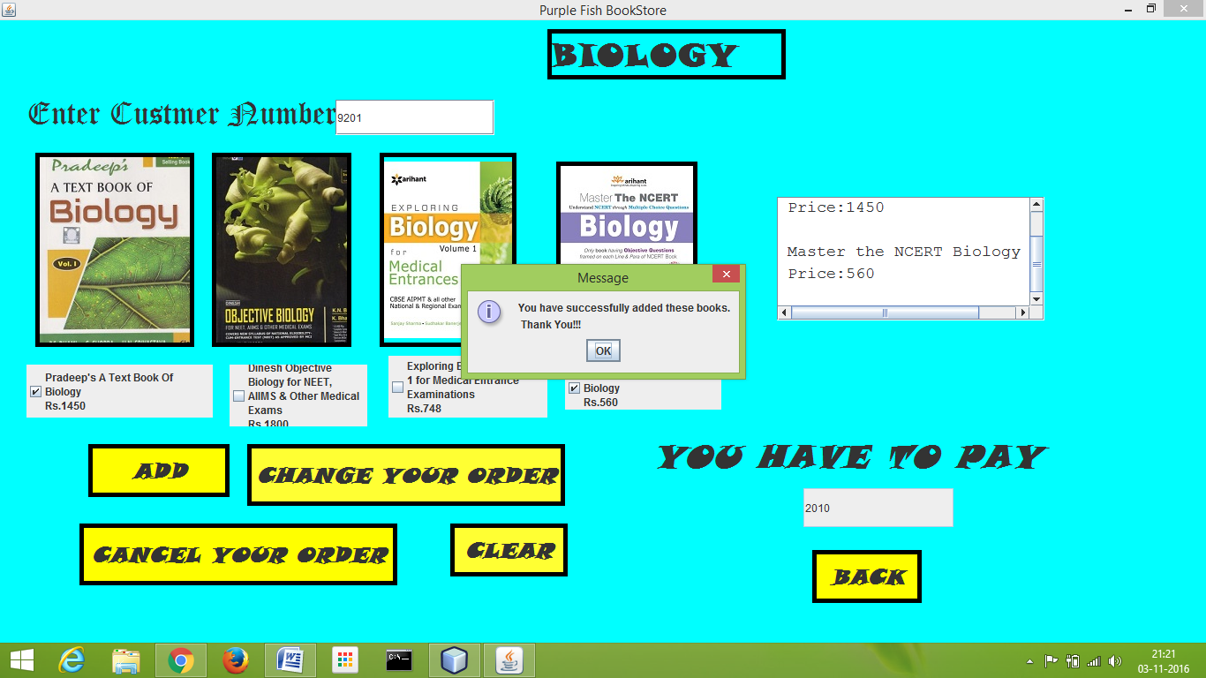

**ADD BUTTON CODING:**

if(t2.equals(" ")) {JOptionPane.showMessageDialog(this,"Enter Customer ID");} try

{ Class.forName("java.sql.Driver");

Connection con=(Connection) DriverManager.getConnection("jdbc:mysql://localhost:3306/ipproject","root","computer");

int k=0;

if(c1.isSelected())

{

jTextArea1.append("\n Pradeep:A textbook of Biology \n Price:1450 \n");

k=k+1450;

}

if(c2.isSelected())

{

k=k+1800;

jTextArea1.append("\n Dinesh Objective Bio NEET \n Price:1800 \n");

}

if(c3.isSelected())

{

k=k+748;

jTextArea1.append("\n Exploring Biology Medical Enterance \n Price:748 \n");

}

if(c4.isSelected())

{

k=k+560;

jTextArea1.append("\n Master the NCERT Biology \n Price:560 \n");

}

jTextField1.setText(Integer.toString(k));

String query="insert intoaddbooksvalues('"+jTextArea1.getText()+"','"+k+"','"+t2.getText()+"');";

Statement stmt=(Statement) con.createStatement(); stmt.executeUpdate(query);

JOptionPane.showMessageDialog(null,"You have successfully added these books.\n Thank You!!! ");

stmt.close();

con.close();

}

catch(Exception e)

{ JOptionPane.showMessageDialog(this,e.getMessage()

);

}

}

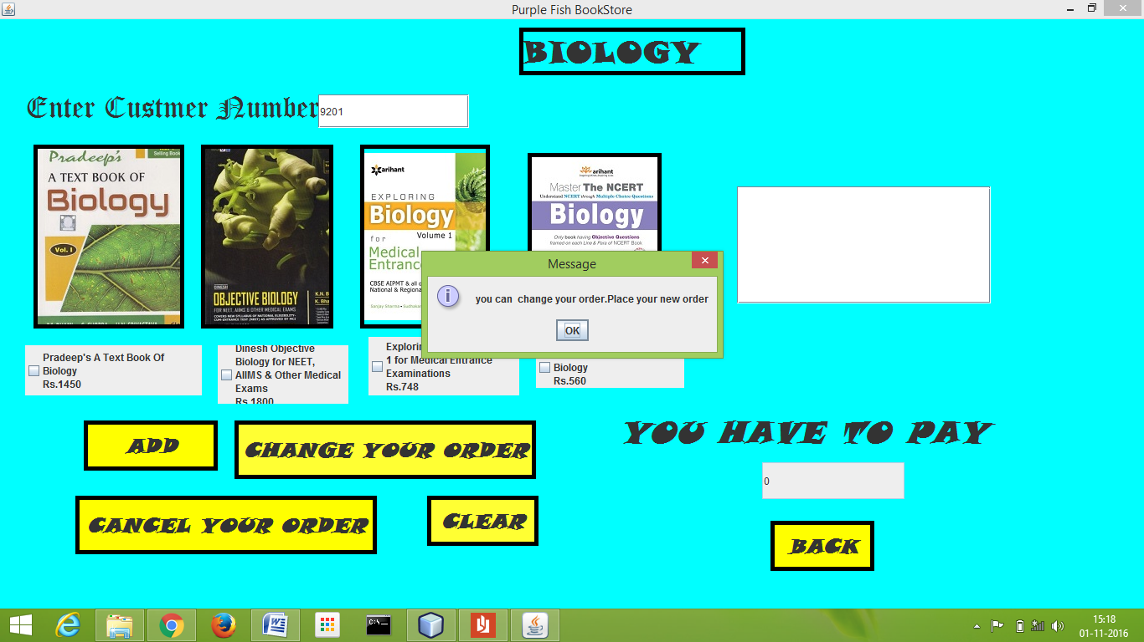

**CHANGE YOUR ORDER BUTTON CODING:**

int cost=Integer.parseInt(jTextField1.getText());

jTextArea1.setText(" ");

jTextField1.setText(" ");

c1.setSelected(false);

c2.setSelected(false);

c3.setSelected(false);

c4.setSelected(false);

try{

Class.forName("java.sql.Driver");

Connection con=(Connection) DriverManager.getConnection("jdbc:mysql://localhost:3306/ipproject","root","computer");

int k=0;

if(c1.isSelected())

{

jTextArea1.append("\n Pradeep:A textbook of Biology \n Price:1450 \n");

k=k+1450;

}

if(c2.isSelected())

{

k=k+1800;

jTextArea1.append("\n Dinesh Objective Bio NEET \n Price:1800 \n");

}

if(c3.isSelected())

{

k=k+748;

jTextArea1.append("\n Exploring Biology Medical Enterance \n Price:748 \n");

}

if(c4.isSelected())

{

k=k+560;

jTextArea1.append("\n Master the NCERT Biology \n Price:560 \n");

}

jTextField1.setText(Integer.toString(k));

String query = "update addbooks set bookname='"+jTextArea1.getText()+"',cost="+cost+" where customer_id="+Integer.parseInt(t2.getText())+";"

Statement stmt=(Statement) con.createStatement();

stmt.executeUpdate(query);

JOptionPane.showMessageDialog(null,"you can change your order.Place your new order");

stmt.close();

con.close();

}

catch(Exception e)

{ JOptionPane.showMessageDialog(this,e.getMessage() );

} }

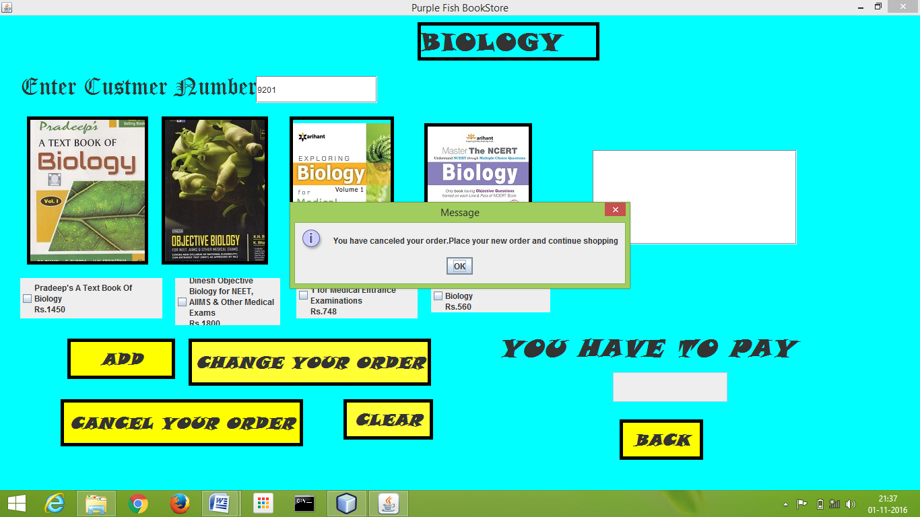

**CANCEL YOUR ORDER BUTTON CODING:**

int id=Integer.parseInt(t2.getText());

jTextArea1.setText(" ");

jTextField1.setText(" ");

c1.setSelected(false);

c2.setSelected(false);

c3.setSelected(false);

c4.setSelected(false);

try{

Class.forName("java.sql.Driver");

Connection con=(Connection) DriverManager.getConnection("jdbc:mysql://localhost:3306/ipproject","root","computer");

String query= "DELETE FROM addbooks WHERE customer_id = "+id+ ";";

Statement stmt=(Statement) con.createStatement();

stmt.executeUpdate(query);

JOptionPane.showMessageDialog(null,"You have canceled your order.Place your new order and continue shopping");

stmt.close();

con.close();

}

catch(Exception e)

{ JOptionPane.showMessageDialog(this,e.getMessage()

);

} }

**CLEAR BUTTON CODING:**

t2.setText(" ");

jTextArea1.setText(" ");

c1.setSelected(false);

c2.setSelected(false);

c3.setSelected(false);

c4.setSelected(false);

**BACK BUTTON CODING:**

this.setVisible(false);

frame3 a=new frame3();

a.setVisible(true);

**MATHEMATICS BOOKSTORE FRAME**

**CODING:**

import com.mysql.jdbc.Connection;

import com.mysql.jdbc.Statement;

import java.awt.Color;

import java.sql.DriverManager;

import javax.swing.JOptionPane;

getContentPane().setBackground(Color.PINK);

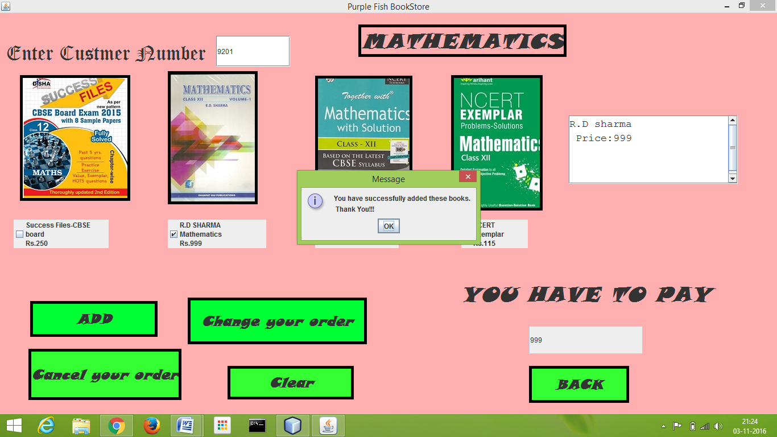

**ADD BUTTON CODING:**

try

{ Class.forName("java.sql.Driver");

Connection con=(Connection) DriverManager.getConnection("jdbc:mysql://localhost:3306/ipproject","root","computer");

int k=0;

if(c1.isSelected())

{

jTextArea1.append("\n Success files \n Price:250 \n");

k=k+250;

}

if(c2.isSelected())

{

k=k+999;

jTextArea1.append("R.D sharma \n Price:999 \n");

}

if(c3.isSelected())

{

k=k+343;

jTextArea1.append("\n Together with \n Price:343 \n");

}

if(c4.isSelected())

{

k=k+115;

jTextArea1.append("\n NCERT Exempler \n Price:115 \n");

}

jTextField1.setText(Integer.toString(k));

String query="insert into addbooks values('"+jTextArea1.getText()+"','"+k+"','"+t2.getText()+"');"; Statement stmt=(Statement) con.createStatement();

stmt.executeUpdate(query);

JOptionPane.showMessageDialog(null," You have successfully added these books. \n Thank You!!! ");

stmt.close();

con.close();

}

catch(Exception e)

{ JOptionPane.showMessageDialog(this,e.getMessage()

);

}

}

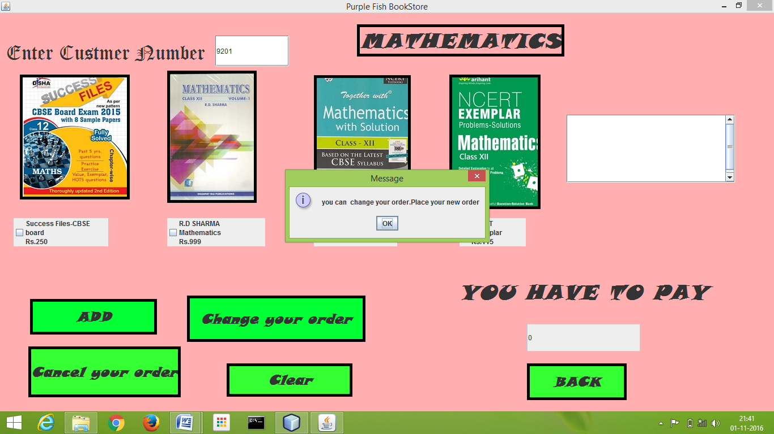

**CHANGE YOUR ORDER BUTTON CODING:**

int cost=Integer.parseInt(jTextField1.getText());

jTextArea1.setText(" ");

jTextField1.setText(" ");

c1.setSelected(false);

c2.setSelected(false);

c3.setSelected(false);

c4.setSelected(false);

try{

Class.forName("java.sql.Driver");

Connection con=(Connection) DriverManager.getConnection("jdbc:mysql://localhost:3306/ipproject","root","computer");

int k=0;

if(c1.isSelected())

{

jTextArea1.append("\n Success files \n Price:250 \n");

k=k+250;

}

if(c2.isSelected())

{

k=k+999;

jTextArea1.append("R.D sharma \n Price:999 \n");

}

if(c3.isSelected())

{

k=k+343;

jTextArea1.append("\n Together with Math \n Price:343 \n");

}

if(c4.isSelected())

{

k=k+115;

jTextArea1.append("\n NCERT Exempler \n Price:115 \n");

}

jTextField1.setText(Integer.toString(k));

String query = "update addbooks set bookname='"+jTextArea1.getText()+"',cost="+cost+" where customer_id="+Integer.parseInt(t2.getText())+";";

Statement stmt=(Statement) con.createStatement();

stmt.executeUpdate(query);

JOptionPane.showMessageDialog(null,"you can change your order.Place your new order");

stmt.close();

con.close();

} catch(Exception e) {

JOptionPane.showMessageDialog(this,e.getMessage());}}

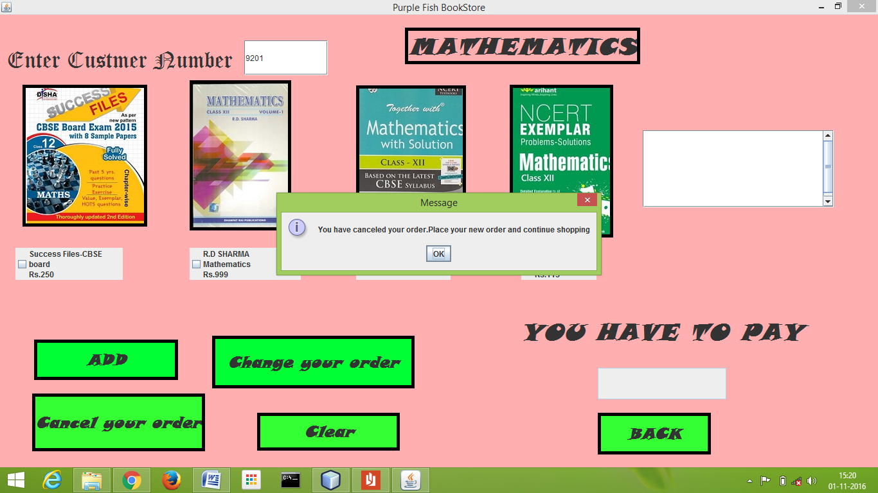

**CANCEL YOUR ORDER BUTTON CODING:**

jTextArea1.setText(" ");

jTextField1.setText(" ");

c1.setSelected(false);

c2.setSelected(false);

c3.setSelected(false);

c4.setSelected(false);

try{

Class.forName("java.sql.Driver");

Connection con=(Connection) DriverManager.getConnection("jdbc:mysql://localhost:3306/ipproject","root","computer");

String query= "DELETE FROM addbooks WHERE customer_id = "+id+ ";";

Statement stmt=(Statement) con.createStatement();

stmt.executeUpdate(query);

JOptionPane.showMessageDialog(null,"You have canceled your order.Place your new order and continue shopping");

stmt.close();

con.close();

}

catch(Exception e)

{ JOptionPane.showMessageDialog(this,e.getMessage() ); } }

**CLEAR BUTTON CODING:**

t2.setText(" ");

jTextArea1.setText(" ");

c1.setSelected(false);

c2.setSelected(false);

c3.setSelected(false);

c4.setSelected(false);

**BACK BUTTON CODING:**

this.setVisible(false);

frame3 a=new frame3();

a.setVisible(true);

**CHEMISTRY BOOKSTORE FRAME**

**CODING:**

import com.mysql.jdbc.Connection;

import com.mysql.jdbc.Statement;

import java.awt.Color;

import java.sql.DriverManager;

import javax.swing.JOptionPane;

getContentPane().setBackground(Color.orange);

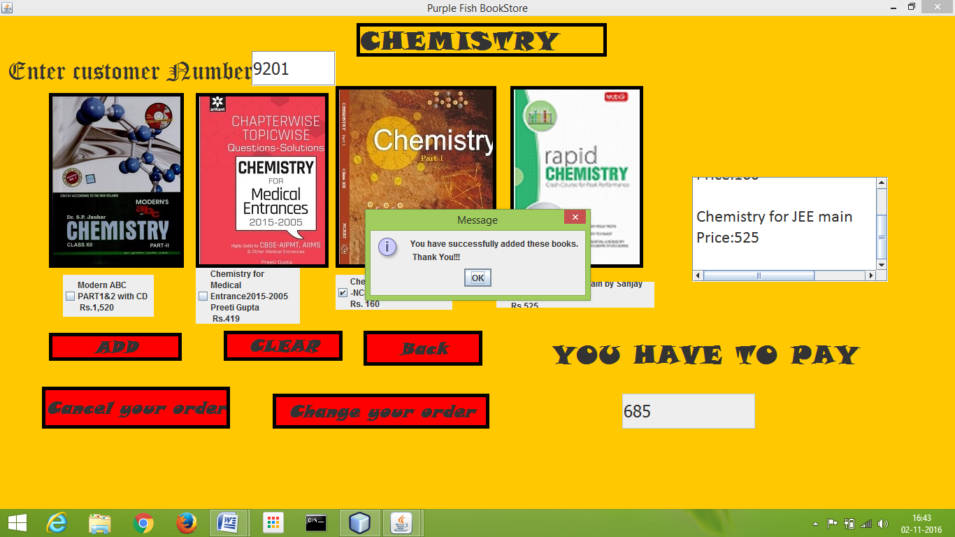

**ADD BUTTON CODING:**

if(t2.getText().isEmpty())

{JOptionPane.showMessageDialog(this,"Enter customer number");}

try

{ Class.forName("java.sql.Driver");

Connection con=(Connection) DriverManager.getConnection("jdbc:mysql://localhost:3306/ipproject","root","computer");

int k=0;

if(c1.isSelected())

{

jTextArea1.append("\n Modren ABC part 1&2 \n Price:1520 \n");

k=k+1520;

}

if(c2.isSelected())

{

k=k+419;

jTextArea1.append("\n Chemistry for medical \n Price:419 \n");

}

if(c3.isSelected())

{

k=k+160;

jTextArea1.append("\n Chemistry part 1 \n Price:160 \n");

}

if(c4.isSelected())

{

k=k+525;

jTextArea1.append("\n Chemistry for JEE main \n Price:525 \n");

} jTextField1.setText(Integer.toString(k));

String query="insert into addbooks values('"+jTextArea1.getText()+"','"+k+"','"+t2.getText()+"');";

Statement stmt=(Statement) con.createStatement();

stmt.executeUpdate(query);

JOptionPane.showMessageDialog(null," You have successfully added these books.\n Thank You!!! ");

stmt.close();

con.close();

}

catch(Exception e)

{ JOptionPane.showMessageDialog(this,e.getMessage()

);

} }

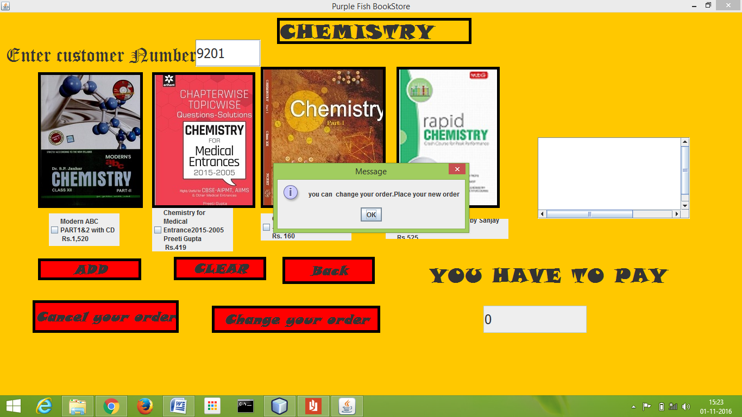

**CHANGE YOUR ORDER BUTTON CODING:**

int cost=Integer.parseInt(jTextField1.getText());

jTextArea1.setText(" ");

jTextField1.setText(" ");

c1.setSelected(false);

c2.setSelected(false);

c3.setSelected(false);

c4.setSelected(false);

try{

Class.forName("java.sql.Driver");

Connection con=(Connection) DriverManager.getConnection("jdbc:mysql://localhost:3306/ipproject","root","computer");

int k=0;

if(c1.isSelected())

{

jTextArea1.append("\n Modren ABC part 1&2 \n Price:1520 \n");

k=k+1520;

}

if(c2.isSelected())

{

k=k+419;

jTextArea1.append("\n Chemistry for medical \n Price:419 \n");

}

if(c3.isSelected())

{

k=k+160;

jTextArea1.append("\n Chemistry part 1 \n Price:160 \n");

}

if(c4.isSelected())

{

k=k+525;

jTextArea1.append("\n Chemistry for JEE main \n Price:525 \n");

} jTextField1.setText(Integer.toString(k));

String query = "update addbooks set bookname='"+jTextArea1.getText()+"',cost="+cost+" where customer_id="+Integer.parseInt(t2.getText())+";"; Statement stmt=(Statement) con.createStatement();

stmt.executeUpdate(query);

JOptionPane.showMessageDialog(null,"you can change your order.Place your new order");

stmt.close();

con.close();

}

catch(Exception e)

{ JOptionPane.showMessageDialog(this,e.getMessage()

);

}

}

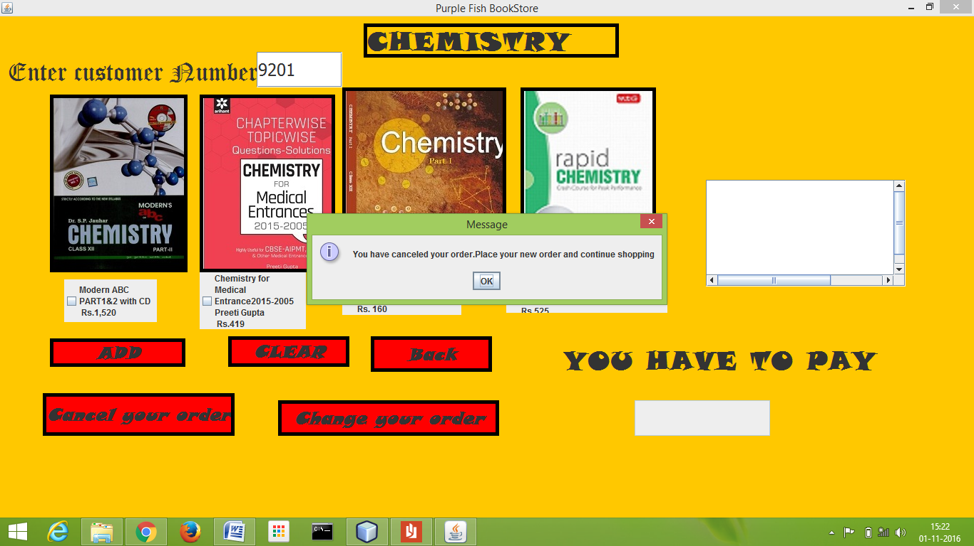

**CANCEL YOUR ORDER BUTTON CODING:**

jTextArea1.setText(" ");

jTextField1.setText(" ");

c1.setSelected(false);

c2.setSelected(false);

c3.setSelected(false);

c4.setSelected(false);

try{

Class.forName("java.sql.Driver");

Connection con=(Connection) DriverManager.getConnection("jdbc:mysql://localhost:3306/ipproject","root","computer");

String query= "DELETE FROM addbooks WHERE customer_id = "+id+ ";";

Statement stmt=(Statement) con.createStatement();

stmt.executeUpdate(query);

JOptionPane.showMessageDialog(null,"You have canceled your order.Place your new order and continue shopping");

stmt.close();

con.close();

}

catch(Exception e)

{ JOptionPane.showMessageDialog(this,e.getMessage()

);

} }

**CLEAR BUTTON CODING:**

jTextArea1.setText(" ");

jTextField1.setText(" ");

c1.setSelected(false);

c2.setSelected(false);

c3.setSelected(false);

c4.setSelected(false);

**BACK BUTTON CODING:**

this.setVisible(false);

frame3 a=new frame3();

a.setVisible(true);

**ECONOMICS BOOKSTORE FRAME**

**CODING:**

import com.mysql.jdbc.Connection;

import com.mysql.jdbc.Statement;

import java.awt.Color;

import java.sql.DriverManager;

import javax.swing.JOptionPane;

getContentPane().setBackground(Color.PINK);

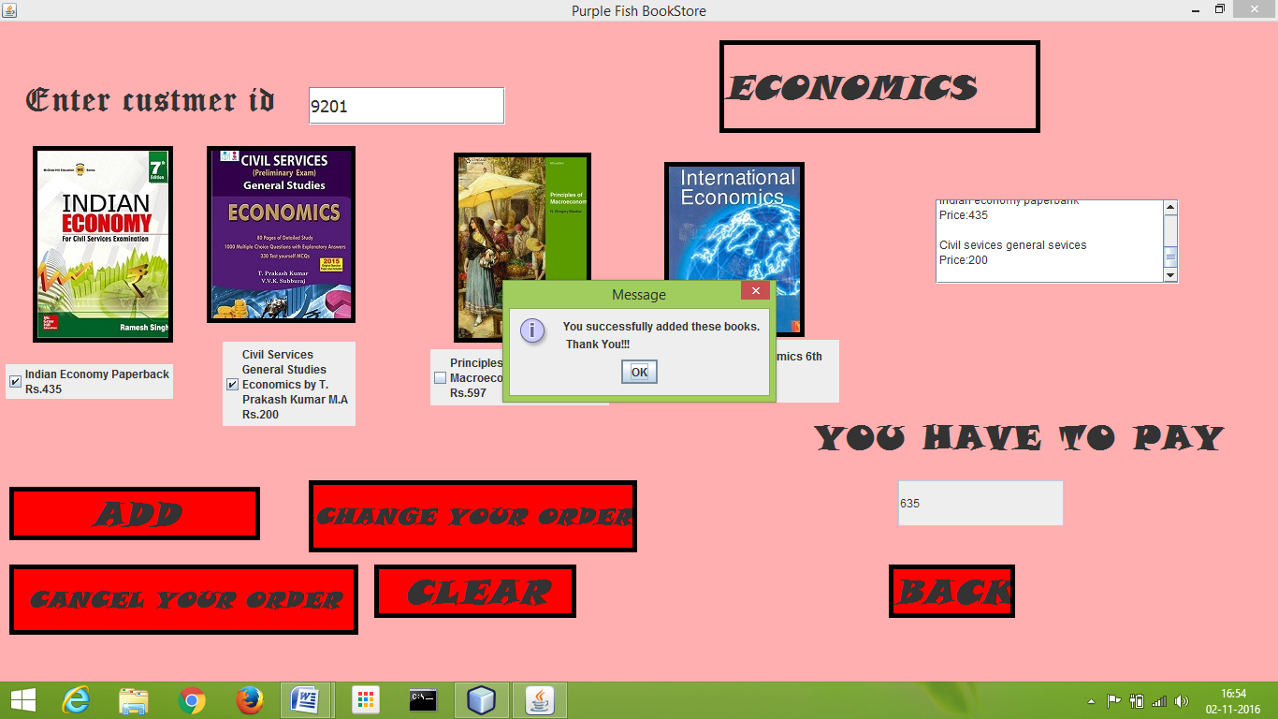

**ADD BUTTON CODING:**

try

{ Class.forName("java.sql.Driver");

Connection con=(Connection) DriverManager.getConnection("jdbc:mysql://localhost:3306/ipproject","root","computer");

int k=0;

if(c1.isSelected())

{

jTextArea1.append("\n Indian economy paperbank \n Price:435 \n");

k=k+435;

}

if(c2.isSelected())

{

k=k+200;

jTextArea1.append("\n Civil sevices general sevices \n Price:200 \n");

}

if(c3.isSelected())

{

k=k+597;

jTextArea1.append("\n principle of macroeconomy \n Price:597 \n");

}

if(c4.isSelected())

{

k=k+238;

jTextArea1.append("\n International economy Price:238 \n");

}

jTextField1.setText(Integer.toString(k));

String query="insert into addbooks values('"+jTextArea1.getText()+"','"+k+"','"+t2.getText()+"');"; Statement stmt=(Statement) con.createStatement();

stmt.executeUpdate(query); JOptionPane.showMessageDialog(null," You have successfully added these books.\n Thank You!!! ");

stmt.close();

con.close();

}

catch(Exception e)

{ JOptionPane.showMessageDialog(this,e.getMessage() );

} }

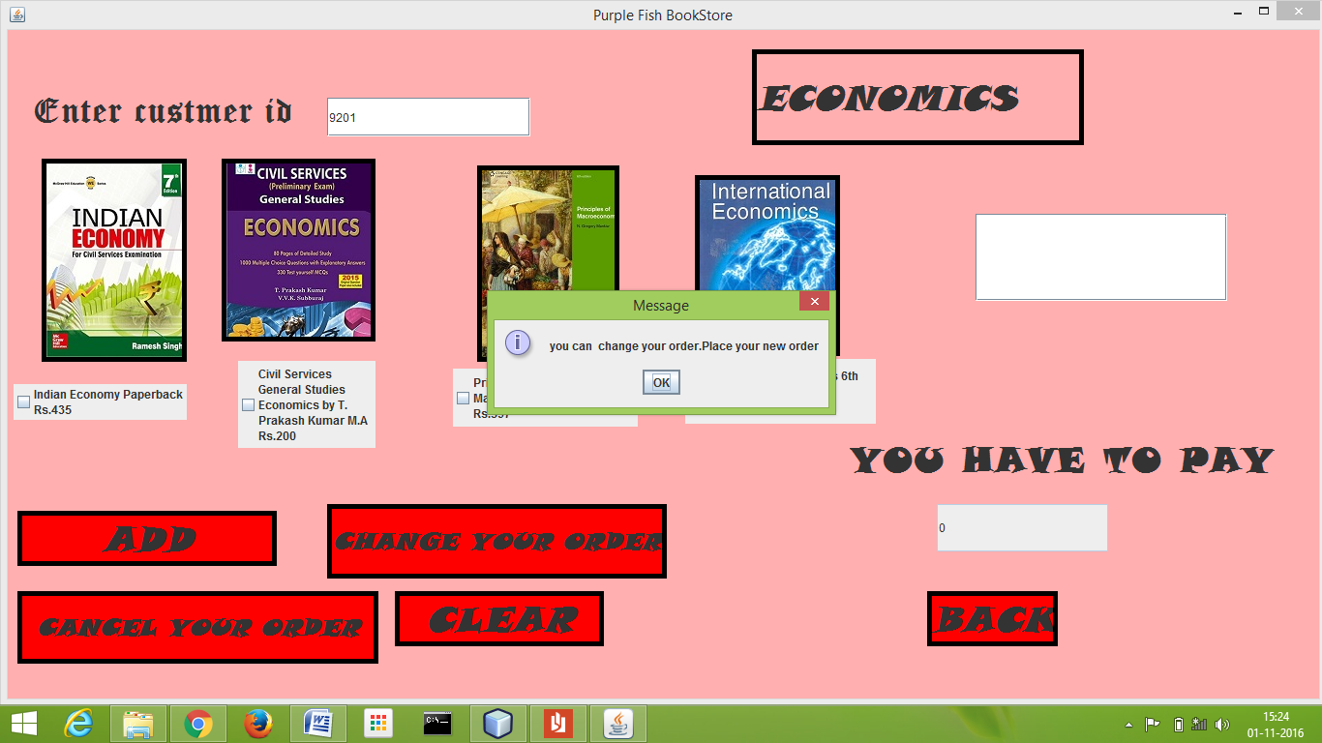

**CHANGE YOUR ORDER BUTTON CODING:**

int cost=Integer.parseInt(jTextField1.getText());

jTextArea1.setText(" ");

jTextField1.setText(" ");

c1.setSelected(false);

c2.setSelected(false);

c3.setSelected(false);

c4.setSelected(false);

try{

Class.forName("java.sql.Driver");

Connection con=(Connection) DriverManager.getConnection("jdbc:mysql://localhost:3306/ipproject","root","computer");

int k=0;

if(c1.isSelected())

{

jTextArea1.append("\n Indian economy paperbank \n Price:435 \n");

k=k+435;

}

if(c2.isSelected())

{

k=k+200;

jTextArea1.append("\n Civil sevices general sevices \n Price:200 \n");

}

if(c3.isSelected())

{

k=k+597;

jTextArea1.append("\n principle of macroeconomy \n Price:597 \n");

}

if(c4.isSelected())

{

k=k+238;

jTextArea1.append("\n International economy Price:238 \n");

}

jTextField1.setText(Integer.toString(k));

String query = "update addbooks set bookname='"+jTextArea1.getText()+"',cost="+cost+" where customer_id="+Integer.parseInt(t2.getText())+";";

Statement stmt=(Statement) con.createStatement();

stmt.executeUpdate(query);

JOptionPane.showMessageDialog(null,"you can change your order.Place your new order");

stmt.close();

con.close();

}

catch(Exception e)

{ JOptionPane.showMessageDialog(this,e.getMessage() );}}

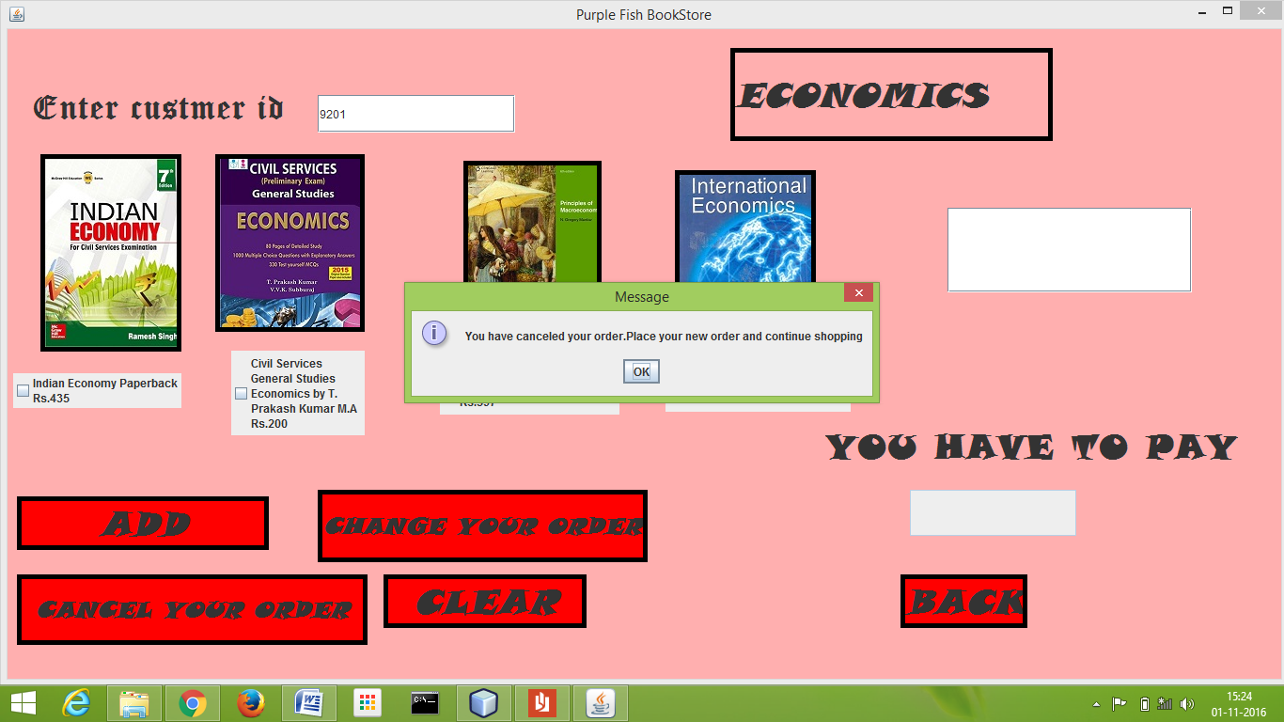

**CANCEL YOUR ORDER BUTTON CODING:**

int id=Integer.parseInt(t2.getText());

jTextArea1.setText(" ");

jTextField1.setText(" ");

c1.setSelected(false);

c2.setSelected(false);

c3.setSelected(false);

c4.setSelected(false);

try{

Class.forName("java.sql.Driver");

Connection con=(Connection) DriverManager.getConnection("jdbc:mysql://localhost:3306/ipproject","root","computer");

String query= "DELETE FROM addbooks WHERE customer_id = "+id+ ";";

Statement stmt=(Statement) con.createStatement();

stmt.executeUpdate(query);

JOptionPane.showMessageDialog(null,"You have canceled your order.Place your new order and continue shopping");

stmt.close();

con.close();

}

catch(Exception e)

{ JOptionPane.showMessageDialog(this,e.getMessage());

} }

**CLEAR BUTTON CODING:**

jTextArea1.setText(" ");

jTextField1.setText(" ");

c1.setSelected(false);

c2.setSelected(false);

c3.setSelected(false);

c4.setSelected(false);

**BACK BUTTON CODING:**

this.setVisible(false);

frame3 a=new frame3();

a.setVisible(true);

**ACCOUNTANCY BOOKSTORE FRAME**

**CODING:**

import com.mysql.jdbc.Connection;

import com.mysql.jdbc.Statement;

import java.awt.Color;

import java.sql.DriverManager;

import javax.swing.JOptionPane;

getContentPane().setBackground(Color.CYAN);

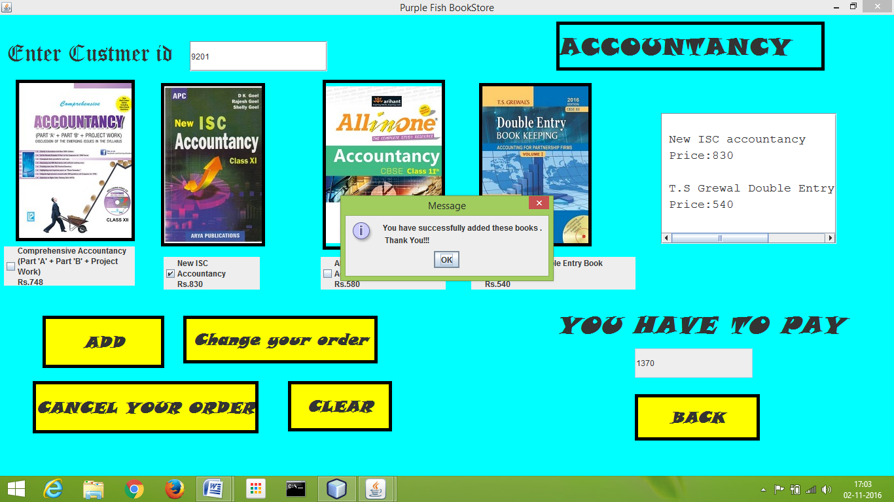

**ADD BUTTON CODING:**

try

{ Class.forName("java.sql.Driver");

Connection con=(Connection) DriverManager.getConnection("jdbc:mysql://localhost:3306/ipproject","root","computer");

int k=0;

if(c1.isSelected())

{

jTextArea1.append("\n Comprehensive Accountancy \n Price:748 \n");

k=k+748;

}

if(c2.isSelected())

{

k=k+830;

jTextArea1.append("\n New ISC accountancy \n Price:830 \n");

}

if(c3.isSelected())

{

k=k+580;

jTextArea1.append("\n All in one-Accountancy \n Price:580\n");

}

if(c4.isSelected())

{

k=k+540;

jTextArea1.append("\n T.S Grewal's Double Entry book keeping \n Price:540 \n");

}

jTextField1.setText(Integer.toString(k));

String query="insert into addbooks values('"+jTextArea1.getText()+"','"+k+"','"+t2.getText()+"');";

Statement stmt=(Statement) con.createStatement();

stmt.executeUpdate(query);

JOptionPane.showMessageDialog(null," You have successfully added these books ./n Thank You!!! ");

stmt.close();

con.close();

}

catch(Exception e)

{ JOptionPane.showMessageDialog(this,e.getMessage()

);

}

}

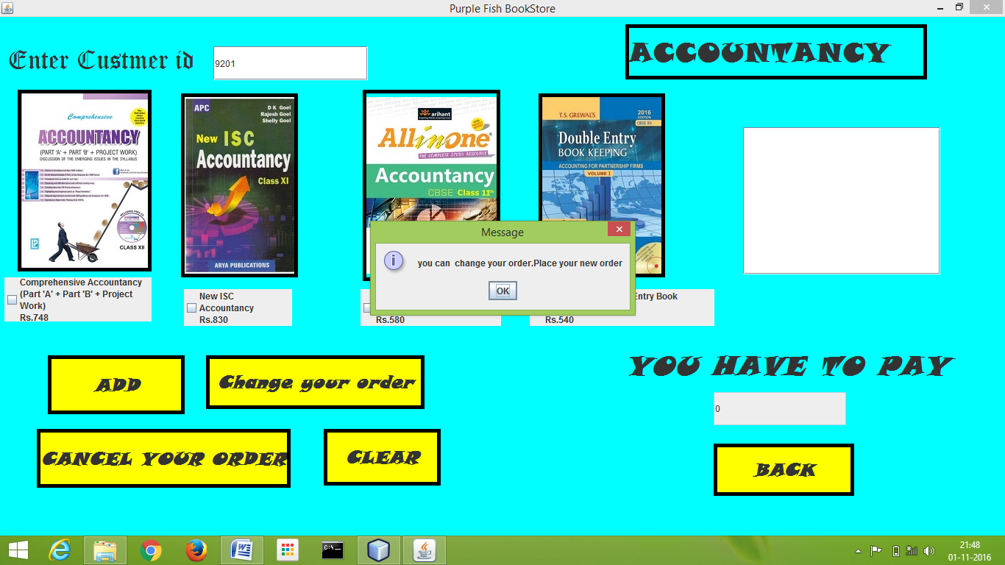

**CHANGE YOUR ORDER BUTTON CODING:**

int cost=Integer.parseInt(jTextField1.getText());

jTextArea1.setText(" ");

jTextField1.setText(" ");

c1.setSelected(false);

c2.setSelected(false);

c3.setSelected(false);

c4.setSelected(false);

try{

Class.forName("java.sql.Driver");

Connection con=(Connection) DriverManager.getConnection("jdbc:mysql://localhost:3306/ipproject","root","computer");

int k=0;

if(c1.isSelected())

{

jTextArea1.append("\n Comprehensive Accountancy \n Price:748 \n");

k=k+748;

}

if(c2.isSelected())

{

k=k+830;

jTextArea1.append("\n New ISC accountancy \n Price:830 \n");

}

if(c3.isSelected())

{

k=k+580;

jTextArea1.append("\n All in one-Accountancy \n Price:580\n");

}

if(c4.isSelected())

{

k=k+540;

jTextArea1.append("\n T.S Grewal's Double Entry book keeping \n Price:540 \n");

}

jTextField1.setText(Integer.toString(k));

String query = "update addbooks set bookname='"+jTextArea1.getText()+"',cost="+cost+" where customer_id="+Integer.parseInt(t2.getText())+";";

Statement stmt=(Statement) con.createStatement();

stmt.executeUpdate(query);

JOptionPane.showMessageDialog(null,"you can change your order.Place your new order");

stmt.close();

con.close();

}

catch(Exception e)

{ JOptionPane.showMessageDialog(this,e.getMessage()

);

}

}

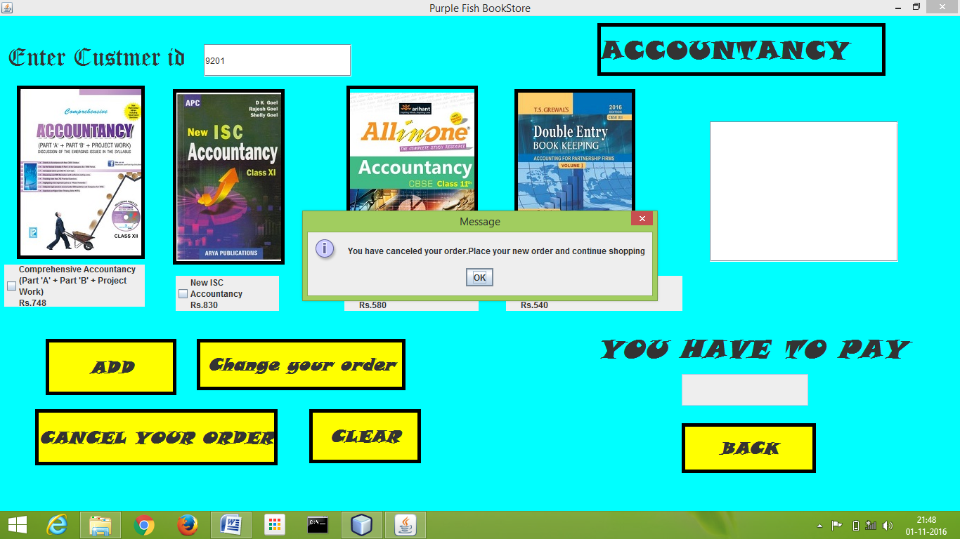

**CANCEL YOUR ORDER BUTTON CODING:**

int id=Integer.parseInt(t2.getText());

jTextArea1.setText(" ");

jTextField1.setText(" ");

jTextField1.setText(" ");

c1.setSelected(false);

c2.setSelected(false);

c3.setSelected(false);

c4.setSelected(false);

try{

Class.forName("java.sql.Driver");

Connection con=(Connection) DriverManager.getConnection("jdbc:mysql://localhost:3306/ipproject","root","computer");

String query= "DELETE FROM addbooks WHERE customer_id = "+id+ ";";

Statement stmt=(Statement) con.createStatement();

stmt.executeUpdate(query);

JOptionPane.showMessageDialog(null,"You have canceled your order.Place your new order and continue shopping");

stmt.close();

con.close();

}

catch(Exception e)

{ JOptionPane.showMessageDialog(this,e.getMessage());

} }

**CLEAR BUTTON CODING:**

jTextArea1.setText(" ");

jTextField1.setText(" ");

c1.setSelected(false);

c2.setSelected(false);

c3.setSelected(false);

c4.setSelected(false);

**BACK BUTTON CODING:**

this.setVisible(false);

frame3 a=new frame3();

a.setVisible(true);

**TIPS FRAME**

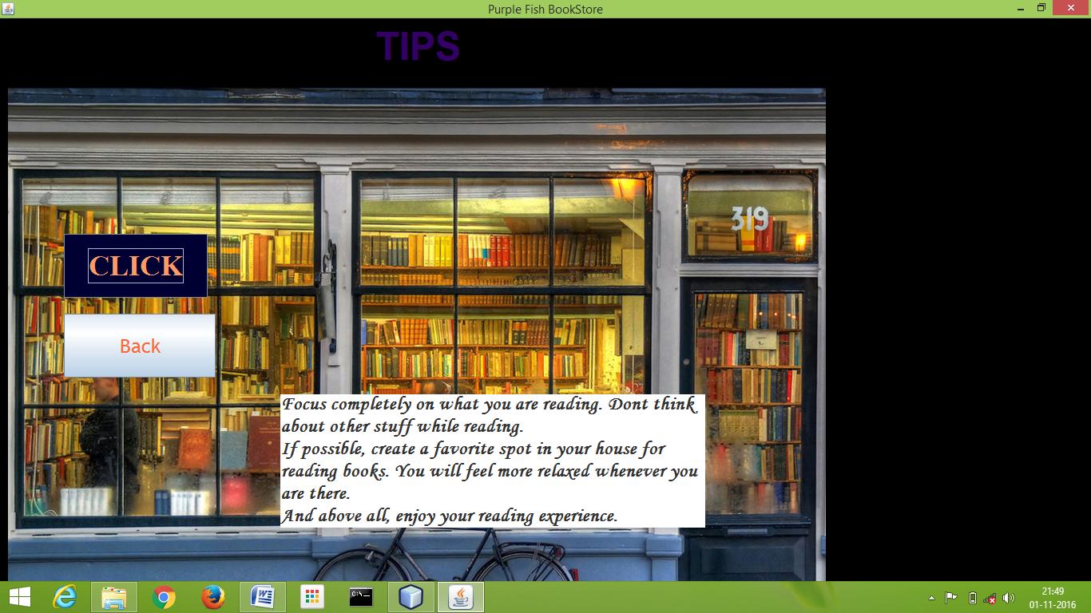

**CODING:**

import java.awt.Color;

getContentPane().setBackground(Color.black);

**BACK BUTTON CODING:**

this.setVisible(false);

frame3 a=new frame3();

a.setVisible(true);

**CLICK BUTTON CODING:**

jTextArea1.setText("Always read your content from a safe distance. Neither too close to your eyes, neither too far away from your eyes."+"Always prefer quality over quantity. Better to read one great book than hundred mediocre ones.\n"+ " Understand properly what you have read and reflect upon it."+ "Don t accept anything blindly that you read, but think for yourself and try to understand the reason behind what has been written.\n"+" Bookmark interesting pages for future references. You never know when you will need them.\n"+ " Sometimes it takes more than one reading to fully grasp something. Dont be disappointed if you dont understand a book in one reading." + "Maybe when you come back to it the next time, you will get it.\n"+ "Focus completely on what you are reading. Dont think about other stuff while reading.\n"+ "If possible, create a favorite spot in your house for reading books. You will feel more relaxed whenever you are there.\n"+ "And above all, enjoy your reading experience.");

**FINAL BILL FRAME**

**CODING:**

import com.mysql.jdbc.Connection;

import com.mysql.jdbc.Statement;

import java.awt.Color;

import java.sql.DriverManager;

import java.sql.ResultSet;

import javax.swing.JOptionPane;

import javax.swing.table.DefaultTableModel;

getContentPane().setBackground(Color.green);

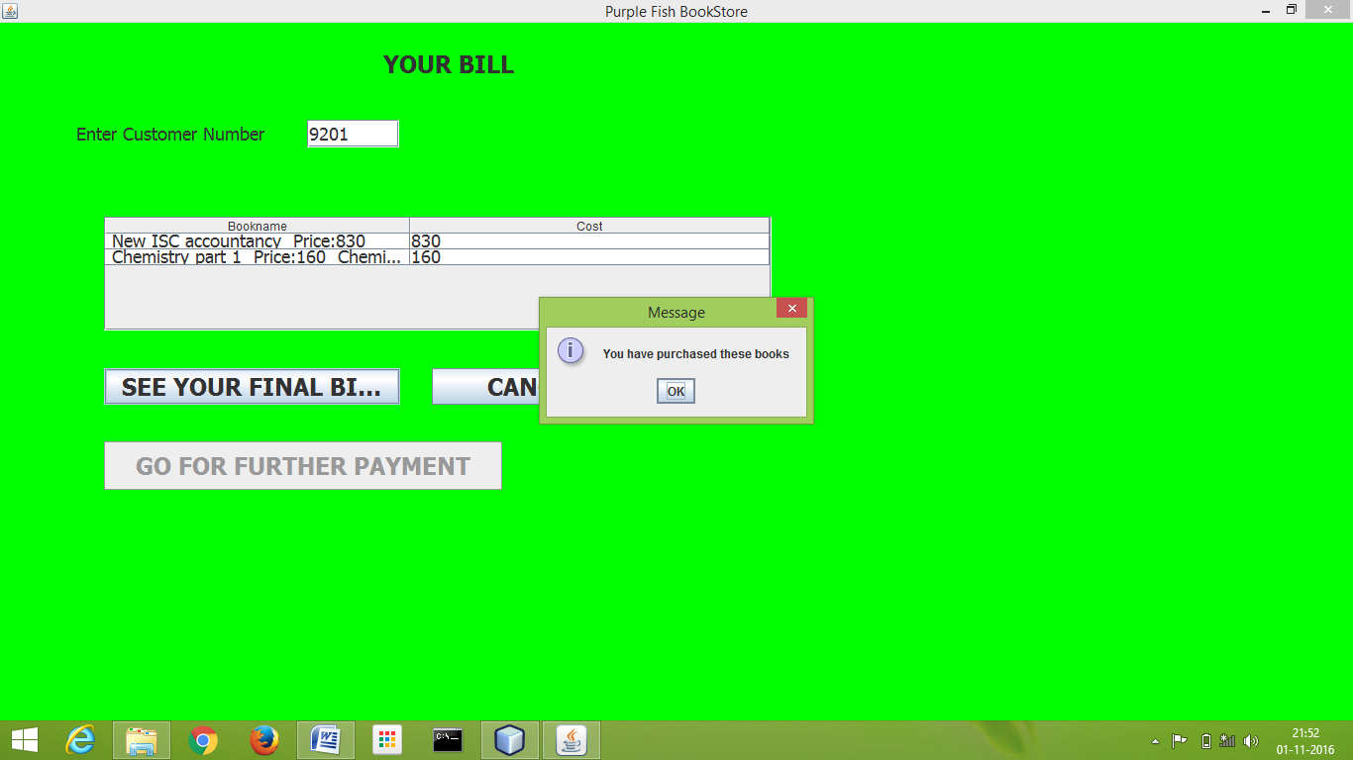

**SEE YOUR FINAL BILLCODING:**

if(t2.getText().isEmpty())

{

JOptionPane.showMessageDialog(this,"Please enter customer id!!!!");

}

jButton3.setEnabled(false);

Integer p=0;

Integer customerID=Integer.parseInt(t2.getText());

DefaultTableModel model=(DefaultTableModel)jTable1.getModel();

int rows=model.getRowCount();

if(rows>0)

{

for(int i=0;i<rows;i++)

model.removeRow(0);

}

try{

Class.forName("java.sql.Driver")

Connection con=(Connection)DriverManager.getConnection("jdbc:mysql://localhost:3306/ipproject","root","computer");

Statement st=(Statement)con.createStatement();

String query="Select*from addbooks where customer_id="+customerID+";"

ResultSet rs=st.executeQuery(query);

while(rs.next()){

String d1=rs.getString("bookname");

Integer d2=rs.getInt("cost");

p=rs.getInt("customer_id");

model.addRow(new Object[]{d1,d2});

}

if (p.equals(customerID))

{

JOptionPane.showMessageDialog(null,"You have purchased these books");

jButton3.setEnabled(true);

jButton2.setEnabled(true);

}

rs.close();

st.close();

con.close(); }

catch(Exception e)

{

JOptionPane.showMessageDialog(this,"Please enter valid customer number");

} }

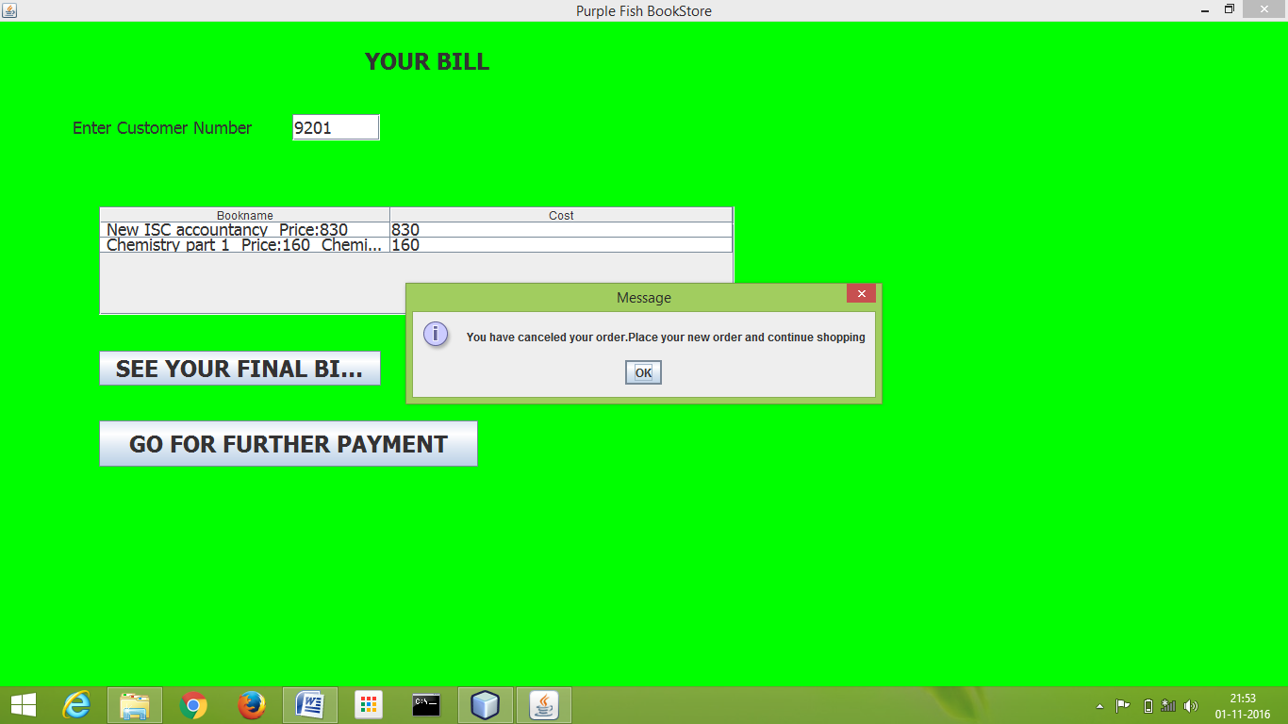

**CANCEL CODING:**

int id=Integer.parseInt(t2.getText());

try{

Class.forName("java.sql.Driver");

Connection con=(Connection) DriverManager.getConnection("jdbc:mysql://localhost:3306/ipproject","root","computer");

String query= "DELETE FROM addbooks WHERE customer_id = "+id+ ";";

Statement stmt=(Statement) con.createStatement();

stmt.executeUpdate(query);

JOptionPane.showMessageDialog(null,"You have canceled your order.Place your new order and continue shopping");

stmt.close();

con.close();

}

catch(Exception e)

{ JOptionPane.showMessageDialog(this,e.getMessage());

}

DefaultTableModel model=(DefaultTableModel)jTable1.getModel();

int rows=model.getRowCount();

if(rows>0)

{

for(int i=0;i<rows;i++)

model.removeRow(0);

JOptionPane.showMessageDialog(this,"Your bill has been cancelled.Continue Shopping!!");

this.setVisible(false);

frame3 a=new frame3();

a.setVisible(true);

}

else if (rows==0)

{

JOptionPane.showMessageDialog(this,"You have not ordered anything");

} }

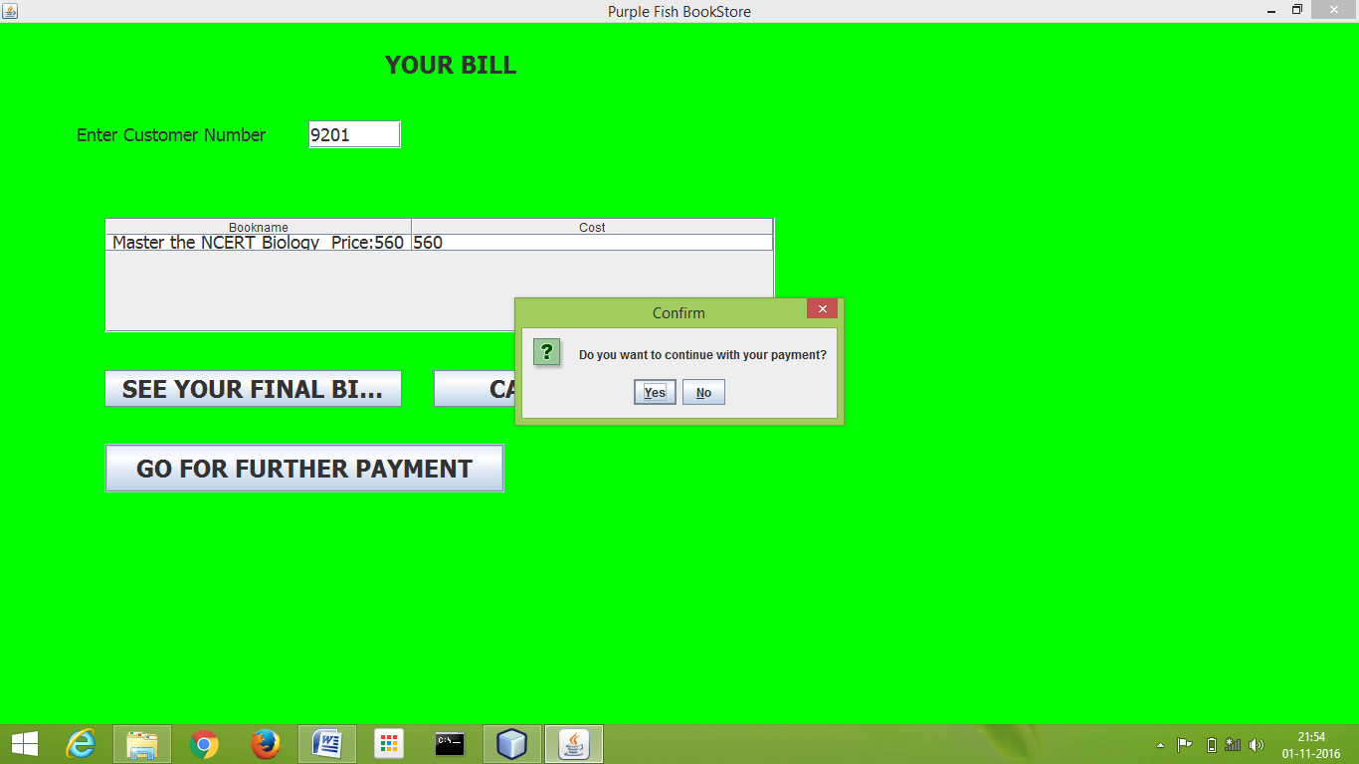

**GO FOR FURTHER PAYMENT CODING:**

int n=JOptionPane.showConfirmDialog(this,"Do you want to continuewithyoupayment?","Confirm",JOptionPane.YES_NO_OPTION);

if(n==0)

{

this.setVisible(false);

debitcard a=new debitcard();

a.setVisible(true);

}

else if(n==1)

this.setVisible(true);

frame3 a=new frame3();

a.setVisible(true);

**CHANGE USER DETAIL FRAME**

**CODING:**

import com.mysql.jdbc.Connection;

import com.mysql.jdbc.Statement;

import java.awt.Color;

import java.sql.DriverManager;

import javax.swing.JOptionPane;

getContentPane().setBackground(Color.pink);

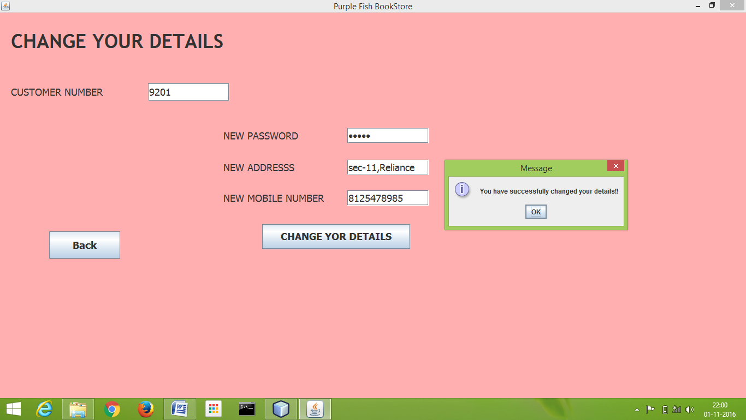

**CHANGER YOUR DETAIL CODING:**

String address=addressTF.getText();

int customer_id=Integer.parseInt(idTF.getText());

String mobileno=mobileTF.getText();

String password=jPasswordField1.getText();

if(mobileno.isEmpty())

{

JOptionPane.showMessageDialog(this,"Please enter all the details completely");

}

else if (mobileno.length() > 10||mobileno.length()<10)

{

JOptionPane.showMessageDialog(this, " Please Enter valid Mobile number"); mobileTF.setText("");

}

else

try{

Class.forName("java.sql.DriverManager");

Connection con=(Connection)

DriverManager.getConnection("jdbc:mysql://localhost:3306/ipproject","root","computer");

Statement st=(Statement)con.createStatement();

String query = "update register set password='"+password+"',mobileno='"+mobileno+"',address='"+address + "' where customer_id="+customer_id+";"; st.executeUpdate(query); JOptionPane.showMessageDialog(this,"You have successfully changed your details!!");

this.setVisible(false);

frame3 a=new frame3();

a.setVisible(true);

}

catch(Exception e)

{JOptionPane.showMessageDialog(this,e.getMessage());

} }

**BACK BUTTON CODING:**

this.setVisible(false);

frame3 a=new frame3();

a.setVisible(true);

**THANK YOU FRAME**



**CODING:**

this.setVisible(false);

frame1 a=new frame1();

a.setVisible(true);

Bibliography

* **Wikipedia.com**
* **Google images**
* **Amazon.com**
* **NCERT TextBook(Class 11 and 12)**